INDIAN HEALTH FINANCING SERIES
Paper I-B · Governance Foundations
Reauthorization of the Indian Health Care Improvement Act
The Critical Year 1999–2000: A Case Study in Tribal-Federal Collaborative Policymaking
Edward J. Fox, PhD
Former Member, CMS Tribal Technical Advisory Group (TTAG), 2003–2021
Northwest Portland Area Indian Health Board · April 2026

Carved mask, gift to the author from the Port Gamble S’Klallam Tribe
Note on Series Placement

This paper appears between Paper I (How We Count Matters) and Paper II (A History of CMS–IHS Tribal Data Improvement) because it addresses the governance event that made those subsequent analyses possible. The statutory architecture the series analyzes—particularly IHCIA Title V governing Urban Indian Organizations, the expanded P.L. 93-638 self-governance compact authority, and the federal consultation framework—was itself the product of a structured, Tribally-driven legislative process. Understanding how that framework was built is essential context for understanding how it functions.
Paper I-B documents that process. Paper II then examines the data infrastructure it enabled.

Abstract
This paper examines the 1999–2000 consultation and drafting process that produced a consensus Tribal proposal for reauthorizing the Indian Health Care Improvement Act (IHCIA). Initiated by the Indian Health Service under Director Dr. Michael Trujillo, the process established a National Steering Committee (NSC) that coordinated extensive Tribal consultation through regional health boards, particularly the Northwest Portland Area Indian Health Board. The collaborative drafting involved Tribal attorneys working under Tribal leadership guidance, with technical support from legal experts and policy advisors. While congressional passage was delayed until 2010—when the IHCIA was permanently reauthorized through incorporation into the Patient Protection and Affordable Care Act—the process represents a significant model of structured Tribal-federal consultation and demonstrates the capacity of indigenous nations to collectively develop sophisticated federal legislative proposals. The statutory provisions produced through
pg. 1

this process constitute foundational architecture for the financing mechanisms and program structures analyzed throughout the Indian Health Financing Series. Importantly, it built relationships between the 12 Areas of IHS that later translated into policy input and success at both the federal and state level for Medicaid and the Affordable Care Act.
Introduction
The Indian Health Care Improvement Act, originally enacted in 1976, represented a landmark federal commitment to addressing health disparities in American Indian and Alaska Native communities. By the late 1990s, evolving health care delivery systems, advances in Tribal self-determination, and emerging public health challenges necessitated comprehensive reauthorization (National Steering Committee, 1999). In 1999, the Indian Health Service (IHS), under the leadership of Director Dr. Michael Trujillo, initiated a federally funded consultation and drafting process designed to produce consensus Tribal legislative language for congressional consideration.
This paper analyzes the organizational structure, consultation methodology, and collaborative drafting process that characterized the 1999–2000 IHCIA reauthorization effort. Particular attention is paid to the roles of regional Tribal health boards, the National Steering Committee, and the legal and policy experts who facilitated the translation of Tribal priorities into legislative text.
The governance process documented here produced the statutory authority that the Indian Health financing system continues to operate under today—including the Title V Urban Indian program and the expanded 638 compact framework that are central to the analytical work in this series.
Organizational Framework and Federal Leadership
The IHS established the National Steering Committee (NSC) as the central coordinating body for the reauthorization effort. Senior IHS officials, including Director Trujillo and Mike Mahsetky and Kitty Marx (who later joined CMS), along with NIHB leadership including Julia Davis, provided administrative oversight and ensured alignment between Tribal recommendations and federal legislative requirements. The NSC was charged with gathering input from Tribes and regional boards, synthesizing recommendations into coherent policy proposals, and drafting legislative language suitable for congressional submission.
The consultation framework recognized the fundamental principle of Tribal sovereignty by establishing mechanisms for direct Tribal participation in legislative development rather than imposing top-down federal proposals. This approach reflected the maturation of Tribal self-determination policy and acknowledged Tribal nations as governmental entities with inherent authority over their citizens’ health and welfare (U.S. Senate Committee on Indian Affairs, 2003).
Regional Consultation and the Role of Tribal Health Boards
Tribal outreach was conducted primarily through contracts with regional Tribal health boards, with the Northwest Portland Area Indian Health Board (NPAIHB) serving as the principal coordination mechanism. The NPAIHB organized consultation meetings across multiple states in the Pacific Northwest, engaging Tribal leadership and technical staff to contribute substantive policy recommendations on health care delivery, facility construction, health professions training, and behavioral health services. A pivotal all-
pg. 2

areas meeting was hosted by NPAIHB in Portland, Oregon, in 1999, bringing together representatives from all IHS Areas (Northwest Portland Area Indian Health Board, 1999–2000).
Julia Davis, serving simultaneously as NPAIHB chair and chair of the National Indian Health Board (NIHB), provided strategic guidance that ensured both regional specificity and national coordination. Her dual leadership position facilitated the integration of geographically diverse Tribal perspectives into a unified legislative framework (Northwest Portland Area Indian Health Board, 1999–2000).
The Alaska Native Health Board (ANHB) played an equally central role in shaping the draft legislation, particularly regarding provisions specific to Alaska Native communities. Myra M. Munson, an attorney and former Alaska Commissioner of Health and Social Services, served as technical advisor to the NSC on behalf of ANHB. Munson assisted in drafting and editing substantial sections of the legislative text, ensuring that Alaska Tribal priorities—including community-based health programs, sanitation infrastructure, and compacting authority under the Indian Self-Determination and Education Assistance Act—were fully incorporated (Alaska Native Health Board, 1999–2000).
Facilitation and Technical Support
The consultation process was facilitated by Kauffman & Associates, Inc., led by Jo Ann Kauffman through an IHS contract. The firm organized meetings, documented discussions, and provided logistical support for the collaborative process. The legislative text itself, however, was drafted collaboratively by attorneys provided by Tribes, working under the guidance of Tribal leaders and their authorized representatives. This distinction is crucial for understanding the authorship and authority of the resulting draft legislation as a genuinely Tribal product rather than a consultant-generated document.
Dr. Edward Fox, PhD, of the Northwest Portland Area Indian Health Board contributed policy and technical expertise, in part funded by IHS, particularly in integrating public health data and Tribal public health priorities into legislative language. This work drew on the analytical tradition—connecting survey-era data to administrative records—that would later characterize the empirical work in this series (Northwest Portland Area Indian Health Board, 1999–2000).
Legal Expertise and Statutory Drafting
The complexity of federal Indian law and health care legislation required specialized legal expertise. Multiple individual Tribes dedicated staff attorney time to the drafting process, and several prominent legal firms contributed technical guidance. Hobbs, Straus, Dean & Walker, LLP, a firm with extensive experience in federal Indian law, provided expert analysis through attorneys Geoffrey Strommer and Carol Barbero, who offered detailed review of statutory language contributing to the legal precision and clarity of the draft legislation (U.S. Senate Committee on Indian Affairs, 2003).
Myra Munson of Sonosky, Chambers (now Sonosky, Chambers, Sachse, Miller and Munson) contributed specifically for the Alaska Area and also served as principal bill drafter and keeper of successive legislative versions throughout the entire drafting history from 1999 through final passage in 2010.
The collaborative legal drafting process demonstrates the sophisticated legal capacity that Tribal nations and their representatives brought to federal legislative development. The involvement of multiple legal practitioners ensured that the draft legislation addressed technical statutory requirements while advancing substantive Tribal policy objectives.
Outcomes and Significance
pg. 3

The NSC process produced a comprehensive draft consensus reauthorization of the IHCIA in 1999–2000 that incorporated broad Tribal input, regional and national perspectives, and expert legal and policy guidance. Although political circumstances delayed congressional passage for a decade, the permanent reauthorization of the IHCIA was ultimately achieved in 2010 through incorporation into the Patient Protection and Affordable Care Act.
The statutory provisions enacted in 2010 include those most consequential for the financing framework this series analyzes: the Title V authorizations governing Urban Indian Organizations (UIOs) analyzed in Papers VI and VII; the self-governance compact provisions under P.L. 93-638 that determine how Tribal health programs access the 100% Federal Medical Assistance Percentage (FMAP) mechanism analyzed in Paper III; and the data and reporting requirements that created regulatory conditions favorable to the CMS–IHS data linkage effort documented in Paper II.
The 1999–2000 drafting process established an important precedent for Tribal-federal collaboration in legislative development. It demonstrated that structured consultation mechanisms, when adequately resourced and organized through trusted Tribal intermediary organizations, can produce sophisticated legislative proposals reflecting genuine Tribal consensus. The process also highlighted the critical role of regional Tribal health boards as institutions capable of coordinating complex multi-Tribal policy development.
Conclusion
The 1999–2000 IHCIA reauthorization process represents a significant case study in collaborative governance within the unique political and legal relationship between the United States and federally recognized Tribal nations. The organizational structure—combining IHS administrative support, regional Tribal health board coordination, expert facilitation, and collaborative legal drafting—created an effective mechanism for translating diverse Tribal priorities into unified legislative language. The efforts of NPAIHB, ANHB, NIHB leadership, and key legal and policy advisors including Julia Davis, Dr. Edward Fox, Myra Munson, Geoffrey Strommer, and Carol Barbero laid essential groundwork for the eventual permanent reauthorization of the IHCIA in 2010.
The statutory framework produced by this process—particularly IHCIA Title V and the expanded 638 compact authority—created the programmatic conditions under which the CMS–IHS data linkage effort, described in the following paper, became both necessary and possible. The legislative architecture built through a decade of Tribal-led drafting now underpins the financing mechanisms, program structures, and data systems that constitute the analytical subject matter of the Indian Health Financing Series.
References
Alaska Native Health Board. (1999–2000). Records and reports on National Steering Committee participation [Unpublished internal documents].
Hobbs, Straus, Dean & Walker, LLP. (n.d.). Professional profiles: Geoffrey Strommer and Carol Barbero. Washington, DC: Author.
National Steering Committee for the Reauthorization of the Indian Health Care Improvement Act. (1999). National Steering Committee. Indian Health Service. https://www.ihs.gov/IHCIA/committee/
Northwest Portland Area Indian Health Board. (1999–2000). Records and reports on consultation process [Unpublished internal documents]. Portland, OR: Author.
U.S. Senate Committee on Indian Affairs. (2003). Statements from the National Steering Committee reauthorization of the IHCIA (Senate Hearing 108-509). U.S. Government Publishing Office.
https://www.govinfo.gov/content/pkg/CHRG-108shrg88509/html/CHRG-108shrg88509.htm
pg. 4

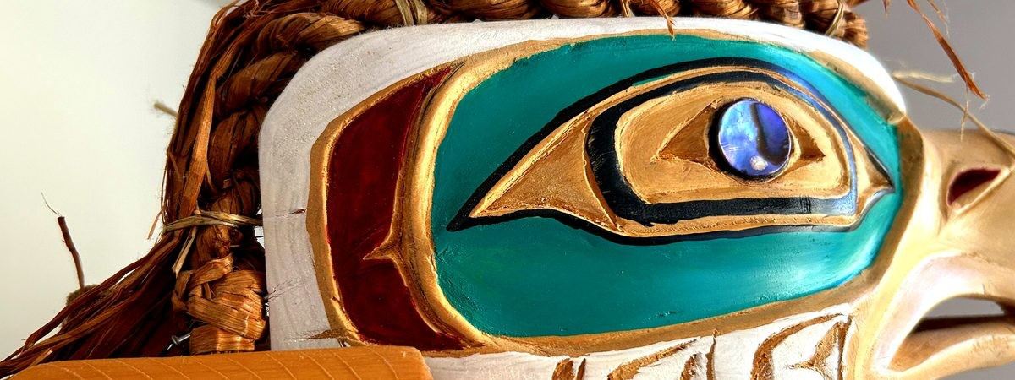
pg. 5

pg. 6

