

Change in the Share of AI/ANs Reporting IHS Access, 2010–2024 | Fox (2026)
INDIAN HEALTH FINANCING SERIES
III. Indian Health Service Access — Trends Analysis
Change in the Share of AI/ANs
Reporting IHS Access, 2010–2024
An Analysis Using ACS HINS7 Across Four 5-Year PUMS Periods
Edward J. Fox, PhD
Indian Health Financing Policy Series (Research Memo)
March 2026
Carved mask, gift to the author from the Port Gamble S’Klallam Tribe
Indian Health Financing Series — Working Paper | March 2026 | 1

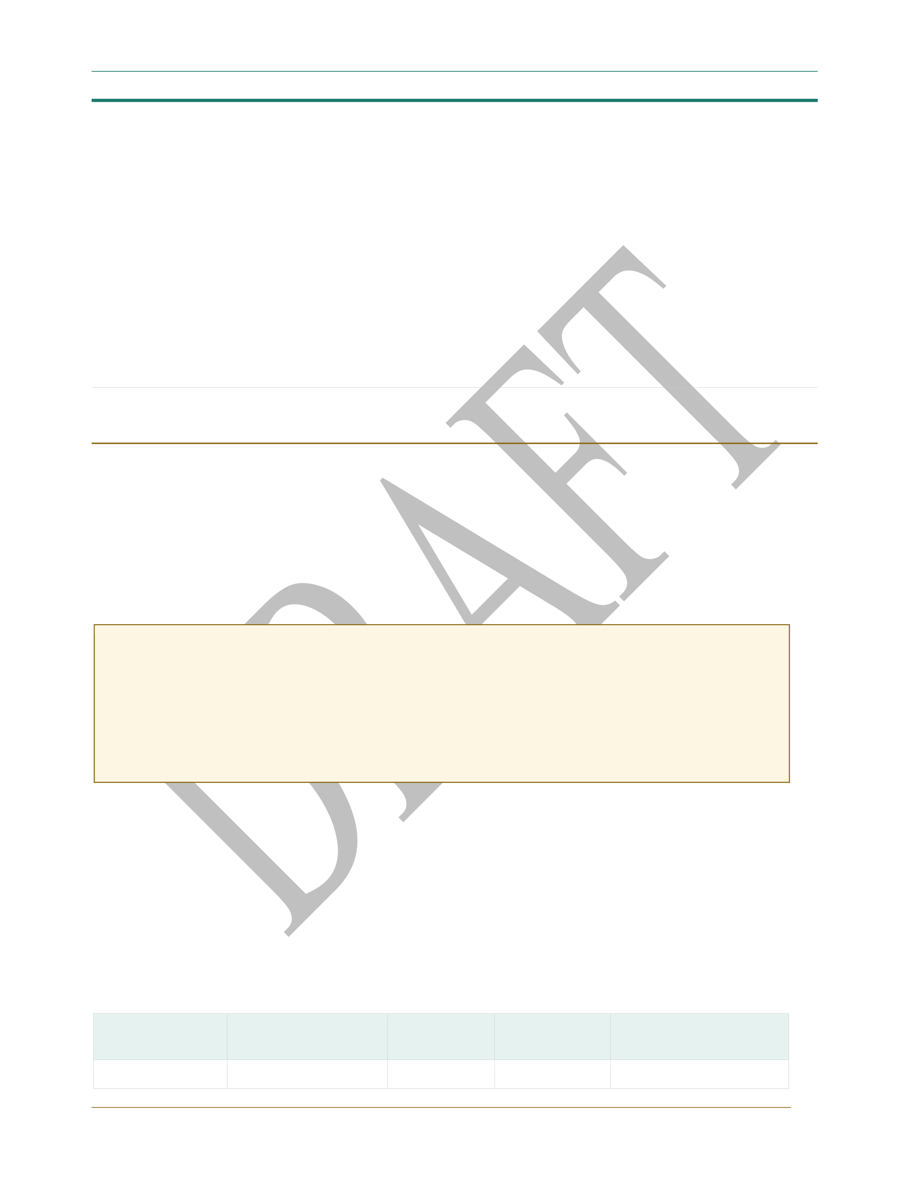
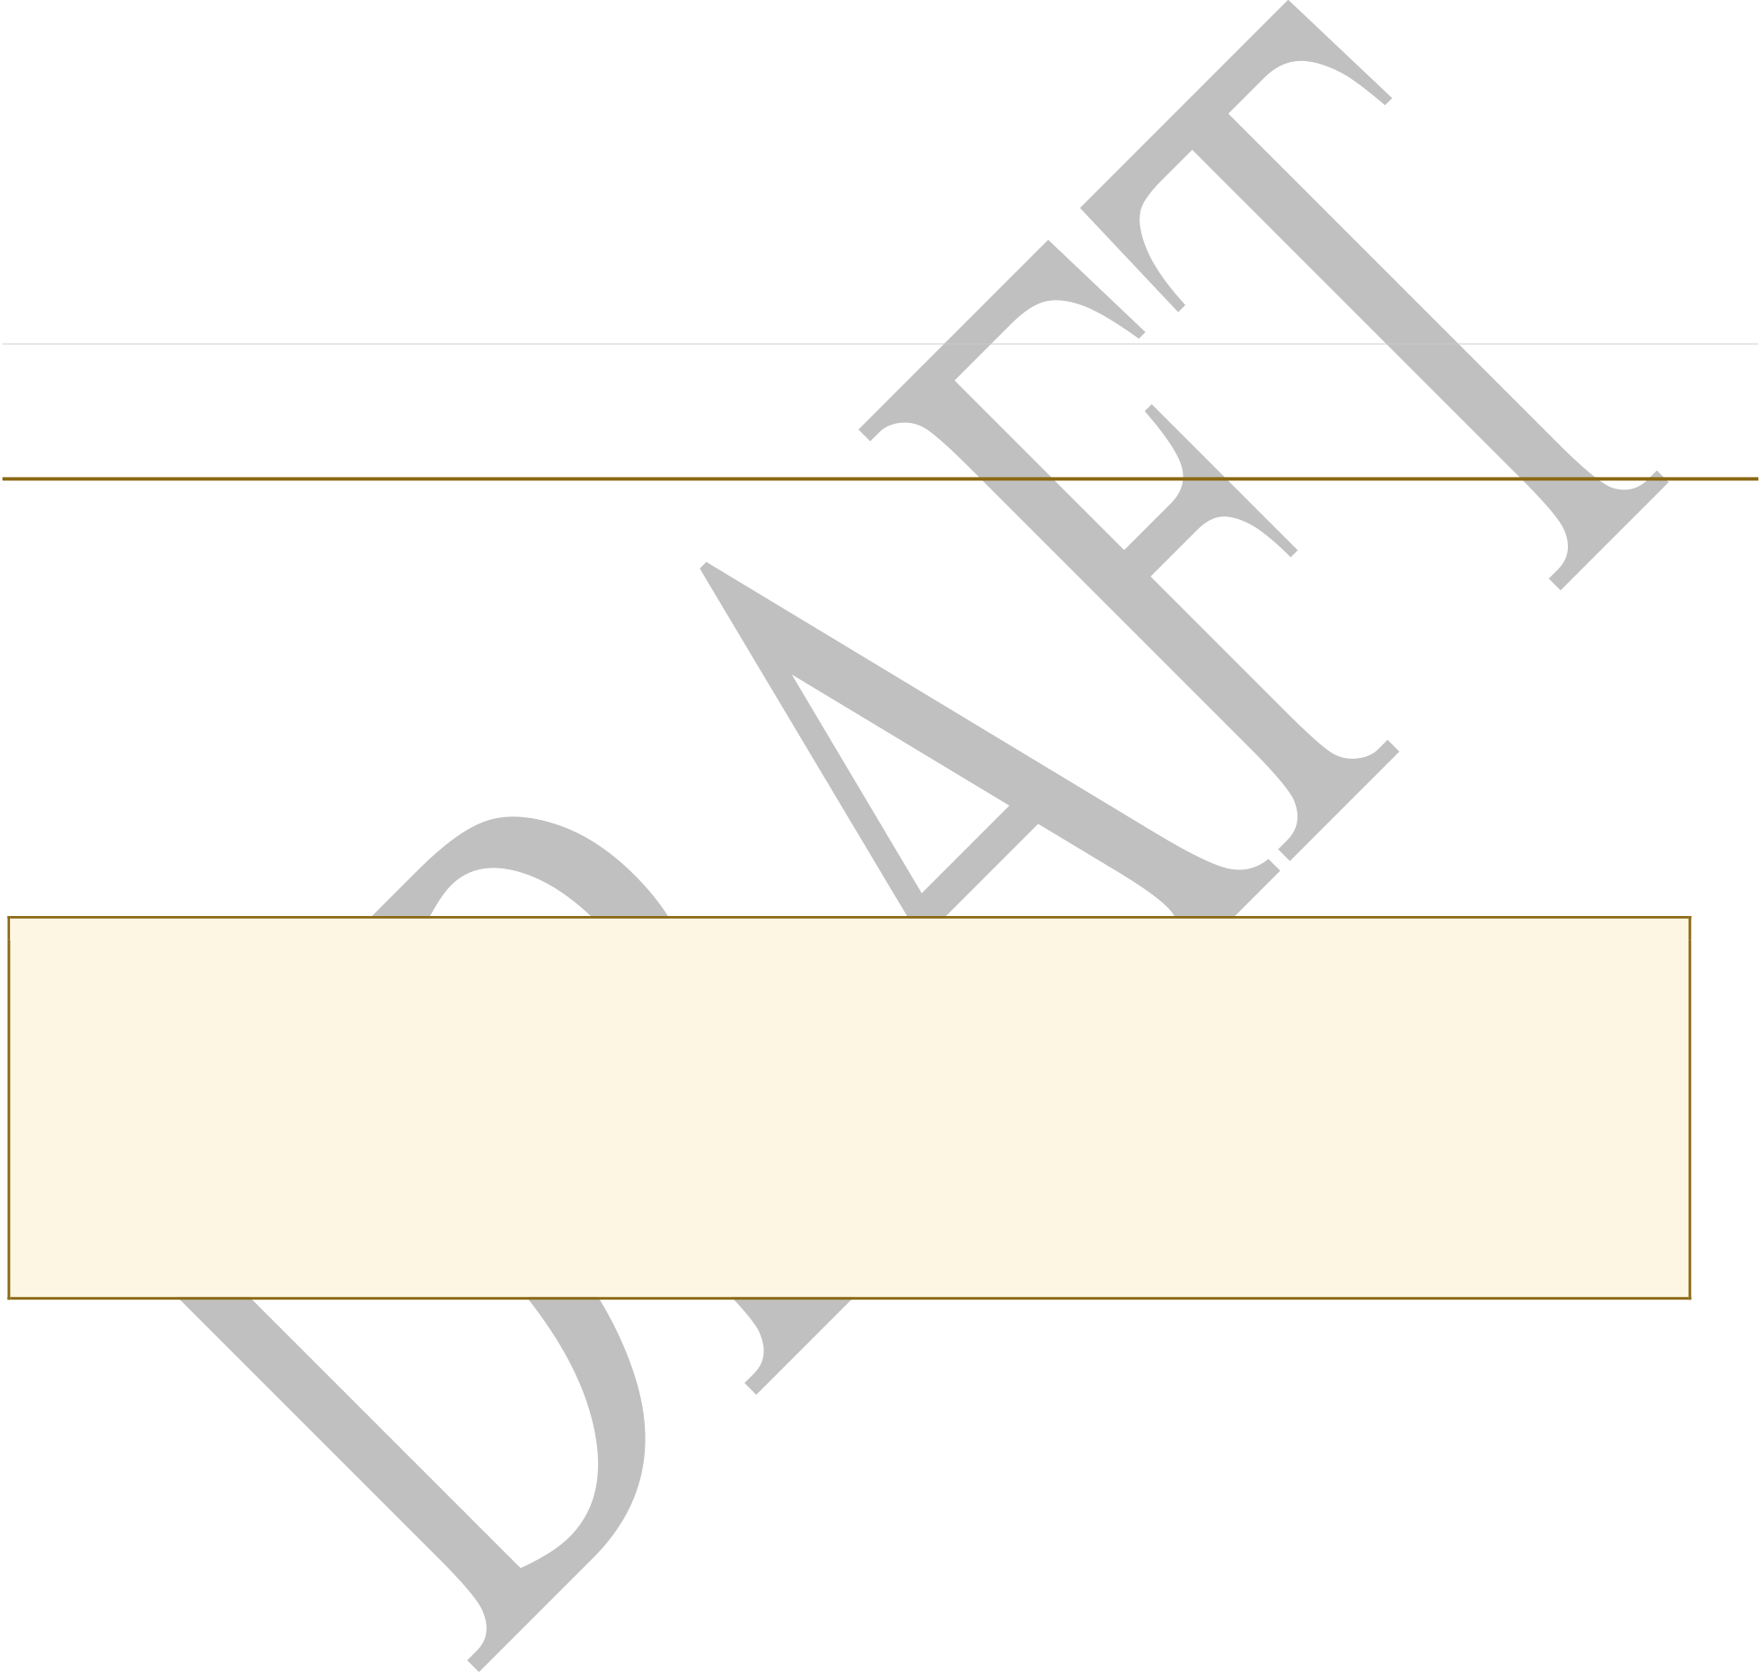
Change in the Share of AI/ANs Reporting IHS Access, 2010–2024 | Fox (2026)
Research Question
How has the share of American Indians and Alaska Natives (AI/ANs) who self-report access to the Indian Health Service changed between 2010 and 2024, as measured by the ACS HINS7 variable?
This question matters for several interconnected reasons. First, IHS access is the
denominator underlying Medicaid billing at the 100% FMAP rate — understanding whether that population is growing or shrinking relative to the total AIAN population has direct fiscal implications. Second, the ACA’s coverage expansions were designed in part to layer insurance coverage on top of IHS access, not replace it. Third, the newly released 2020–2024 ACS 5-year PUMS provides the first opportunity to observe IHS access reporting in the post-pandemic, post-late-expansion period.
Methodology and Data Sources
The HINS7 Variable
The ACS health insurance question (HINS7) was introduced in 2008 and asks whether the respondent is covered by Indian Health Service. Importantly, IHS coverage is not counted as health insurance under the Census definition — persons with only HINS7 coverage are classified as uninsured. This makes HINS7 a distinct, standalone measure of IHS access separate from the standard insurance coverage recode (HICOV).
MEASUREMENT CAVEAT: HINS7 IS A FLOOR ESTIMATE
The Bhaskar et al. (2018) linkage study found a ~25% false-negative rate for IHS coverage in the 2014 ACS — meaning roughly 1 in 4 active IHS users did not report IHS access on the survey. Additionally, the IPUMS logical edit removes IHS coverage for anyone who does not identify as AIAN alone (excluding multiracial respondents). Both factors mean HINS7-based counts systematically undercount the true IHS-access population. Trends over time are more reliable than point estimates, assuming the undercount rate is roughly stable.
Analysis Design: Four Non-Overlapping 5-Year Windows
To track change from 2010 to 2024, the analysis uses four non-overlapping ACS 5-year PUMS datasets. Note: The 2019–2023 PUMS (used in prior Fox analyses) overlaps with both the 2015–2019 and 2020–2024 windows and is not included in this four-period design to avoid double-counting years. However, the 2019–2023 national estimate (1,937,687 AIAN with HINS7=Yes; 77.3% insured rate) from prior work is available as an interpolation anchor.
Table 1. Four Non-Overlapping 5-Year PUMS Windows for Longitudinal HINS7 Analysis
5-Year PUMS Period | Years Covered | Midpoint Year | Status | Primary Policy Context
2008–2012 | 2008–2012 | 2010 | Available | Pre-ACA baseline

Indian Health Financing Series — Working Paper | March 2026 | 2



Change in the Share of AI/ANs Reporting IHS Access, 2010–2024 | Fox (2026)
ACA implementation;
2013–2017 | 2013–2017 | 2015 | Available | early Medicaid
expansion
2015–2019 | 2015–2019 | 2017 | Available | ACA consolidation; pre-
 |  |  |  | pandemic
2020–2024 | 2020–2024 | 2022 | Released | Post-pandemic; late
 |  |  |  | Medicaid expansion
2020–2024 | 2020–2024 | 2022 | March 5, 2026 | Medicaid expansion
 |  |  |  | states
Computation
For each 5-year PUMS, the core calculation estimates the percentage of AI/ANs reporting IHS access. All estimates use person-level weights (PWGTP). AIAN identity is defined as RACAIAN=1 (alone or in combination) for the denominator; the HINS7 numerator uses the same universe.
Table 2. Core Computation for Each PUMS Period
Numerator | Denominator | Result
AIAN persons with HINS7=Yes | Total AIAN persons (RACAIAN=1, | % of AI/ANs reporting
(weighted) | alone or in combination) | IHS access
What Published Sources Already Tell Us
National IHS Service Population (Administrative Data)
IHS administrative data provides a parallel trend line, though measuring a different concept (registered patients, not self-reported access). The administrative figures count all registered IHS users, regardless of ACS survey response. The ACS HINS7 self-report measure will be lower due to the ~25% false-negative rate documented by Bhaskar et al.
Table 3. IHS Administrative User Population as Share of Total AIAN, Select Years
Year | IHS User Pop. (Administrative) | Total AIAN Pop. | IHS % of | Source
Year | IHS User Pop. (Administrative) | Total AIAN Pop. | AIAN | Source
~2011 | ~2.56 million | ~5.2 million | ~49% | IHS Disparities
 |  |  |  | Fact Sheet
~2014 | ~2.2 million (est.) | ~5.4 million | ~41% | CARRA 2018
 |  |  |  | linkage estimate
~2020 | ~2.56 million | ~5.9 million | ~43% | Office of Minority
 |  |  |  | Health 2024
~2024 | ~2.6 million | ~6.0 million (est.) | ~43% | IHS Division of
 |  |  |  | Program Statistics
Indian Health Financing Series — Working Paper |  |  |  | March 2026 | 3

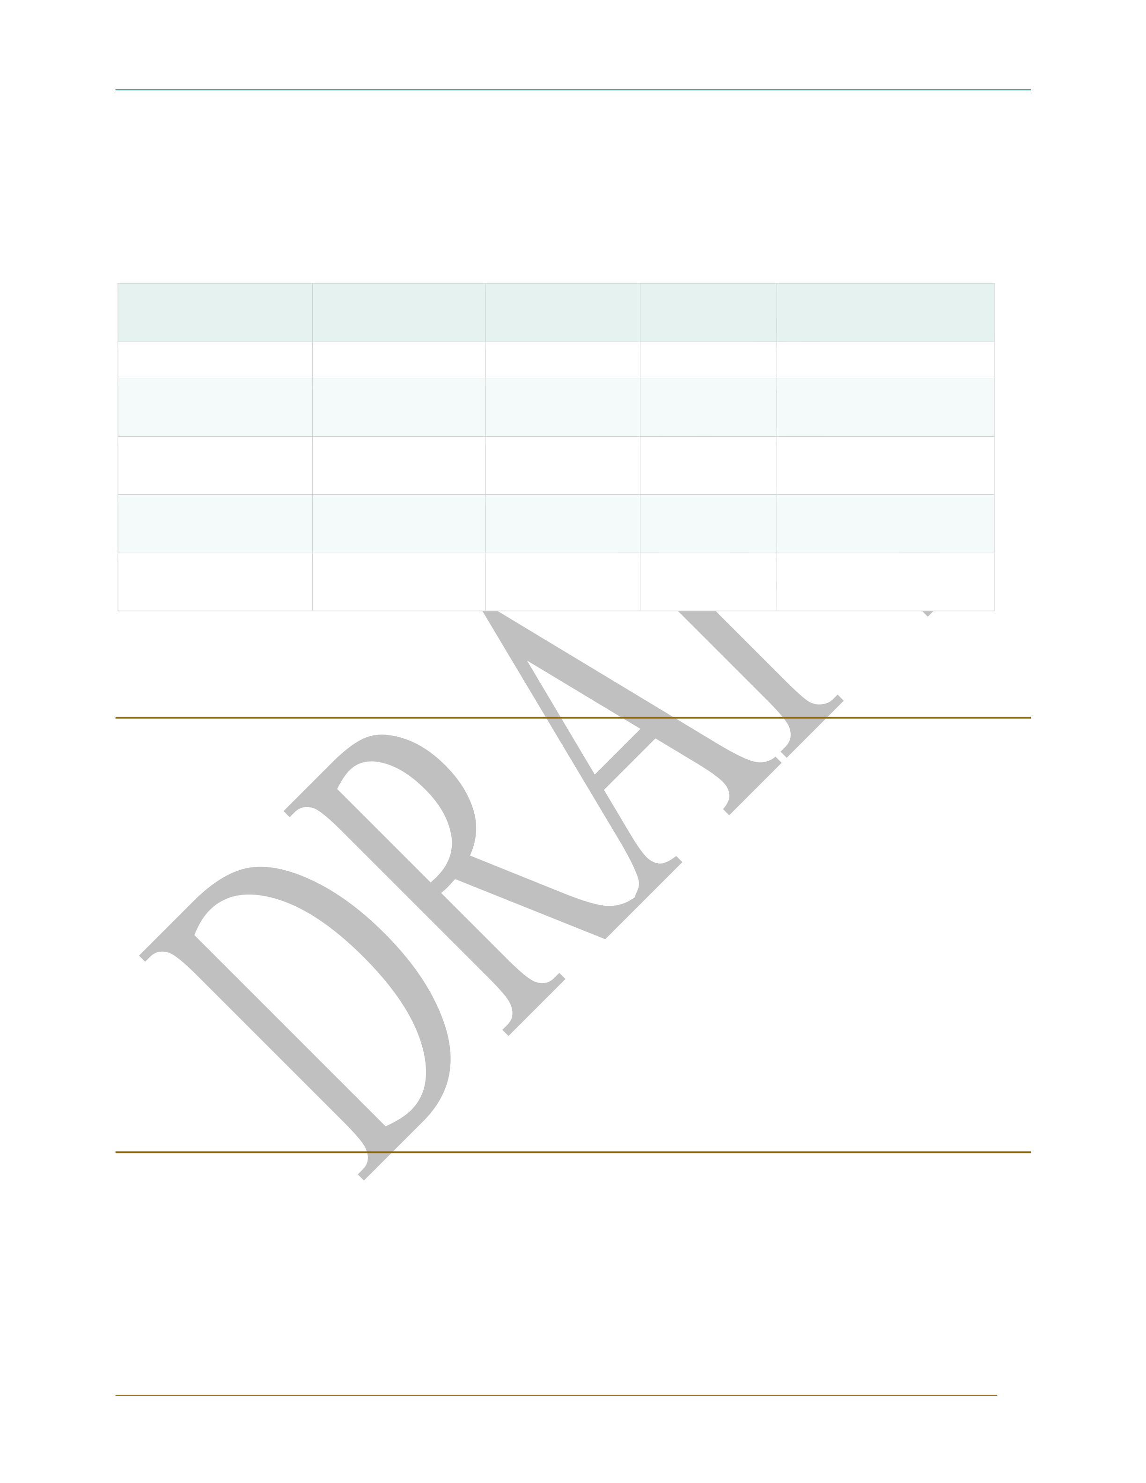
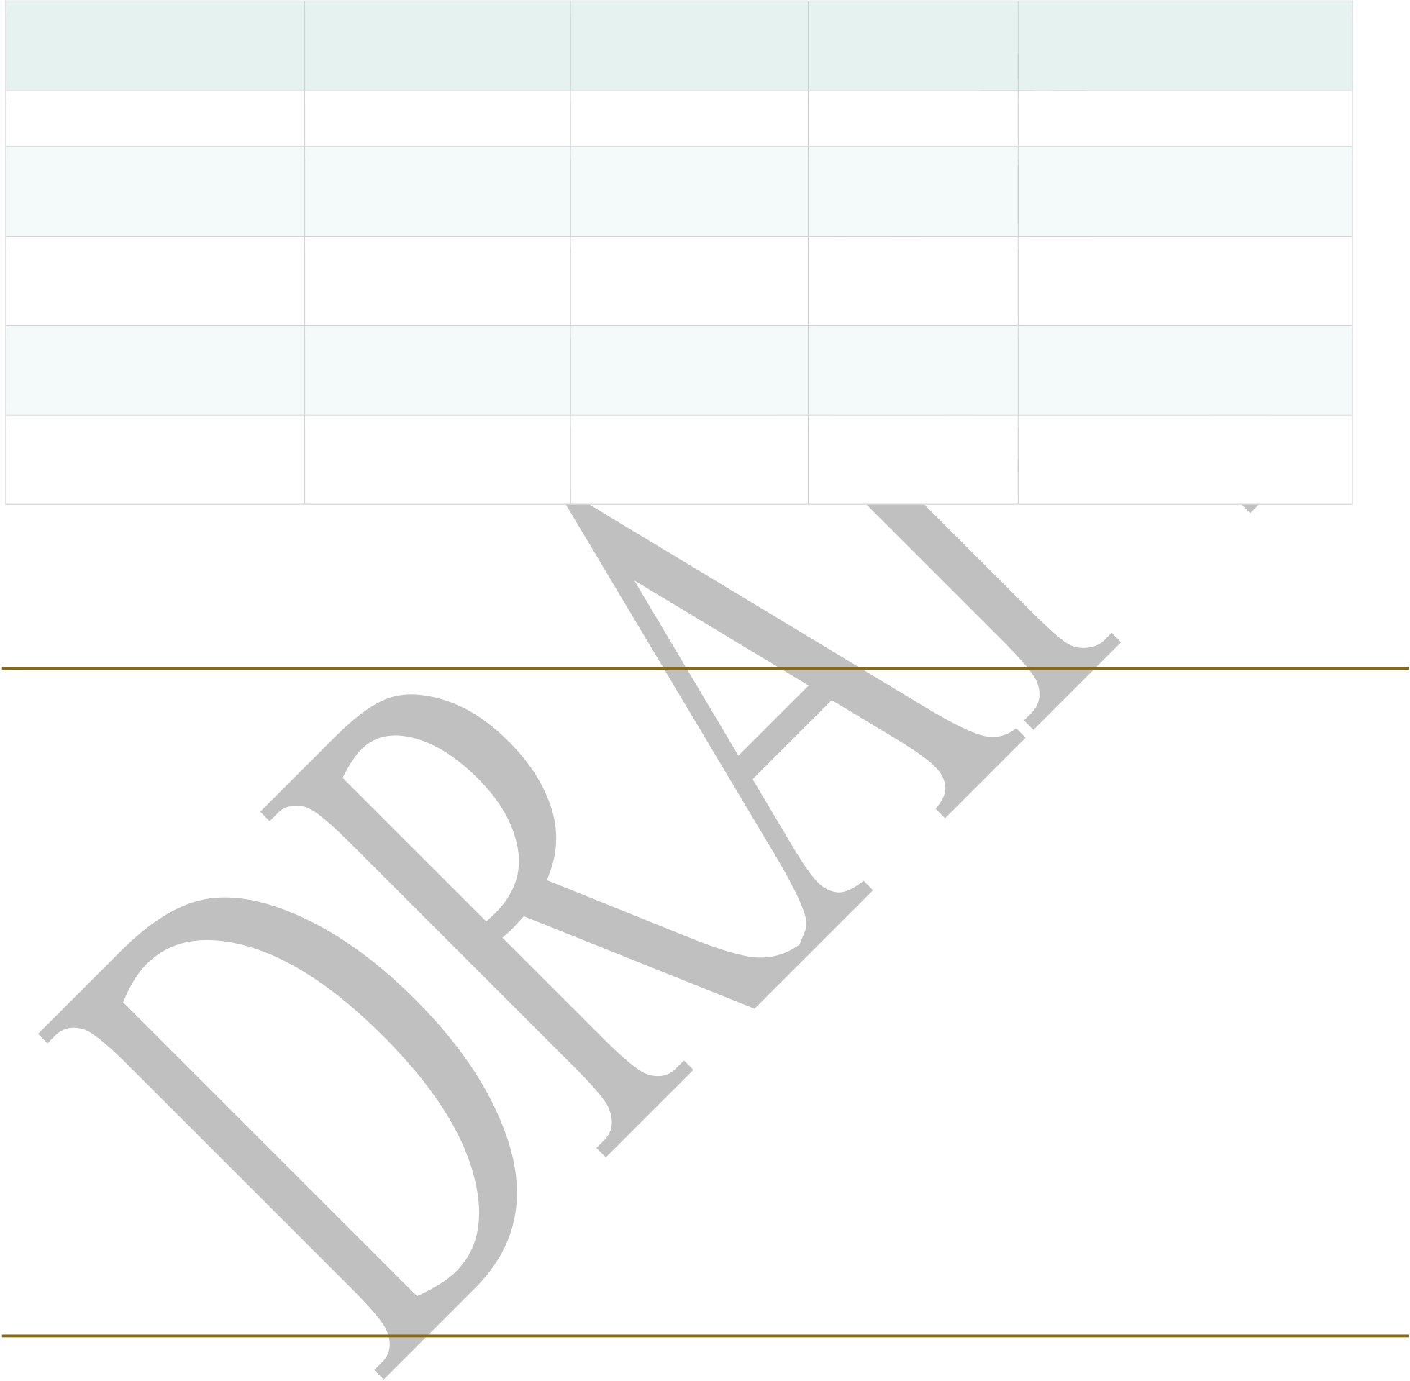
Change in the Share of AI/ANs Reporting IHS Access, 2010–2024 | Fox (2026)
ACS HINS7 Data: What We Have From Prior Analysis
From the November 2025 Fox analysis using the 2019–2023 ACS 5-year PUMS, two anchor data points are available. The three PUMS runs marked “PENDING” below require execution of the PUMS extraction script to complete the longitudinal series.
Table 4. Available HINS7 Estimates; Cells Marked PENDING Require the PUMS Run Script
PUMS Period | AIAN with | Total AIAN | HINS7 Share | Insured Rate Among
PUMS Period | HINS7=Yes | Pop. | HINS7 Share | HINS7=Yes
2013 (prior work) | ~1,275,712 | ~5,130,103 | ~24.9% | 63.4%
2019–2023 (prior | ~1,937,687 | ~7,312,161 | ~26.5% | 77.3%
work)
2008–2012 | PENDING PUMS | — | — | —
2008–2012 | RUN | — | — | —
2013–2017 | PENDING PUMS | — | — | —
2013–2017 | RUN | — | — | —
2020–2024 | PENDING PUMS | — | — | —
2020–2024 | RUN | — | — | —
Preliminary Interpretation of Available Data
The two data points from prior analysis (2013 baseline and 2019–2023 endpoint) already suggest a meaningful finding: the HINS7 share of the total AIAN population appears to have increased modestly, from approximately 24.9% to 26.5%, even as the total AIAN population grew by 42.5%. In absolute terms, the IHS-access subpopulation grew faster (51.9%) than the total AIAN population, suggesting the IHS-access group is a growing, not shrinking, share of the AIAN population.
This is a counterintuitive finding worth investigating with the full four-period series. Possible explanations include: improved ACS survey capture of IHS-eligible populations on and near reservations; growth of tribally operated programs (PL 638 compacts) increasing registration; Medicaid expansion creating new touchpoints that prompted IHS registration; and demographic concentration, with reservation-based IHS-access populations growing faster than urban AIAN populations.
State-Level Analysis Framework
The state-level analysis examines divergent trends across three state typologies: Southwest states (Arizona, New Mexico, Utah) show growth in reported IHS access corresponding to Tribal facility expansion under PL 638 self-governance. Pacific Northwest, Northern Plains, and Upper Midwest states show declining access shares, interpreted as reflecting capacity constraints rather than reduced need. These state-level patterns connect directly to Medicaid financing implications, particularly the relationship between IHS user population size and 100 percent FMAP expenditure levels.
Indian Health Financing Series — Working Paper | March 2026 | 4



Change in the Share of AI/ANs Reporting IHS Access, 2010–2024 | Fox (2026)
The Bhaskar et al. (2018) finding that HINS7 undercounts active IHS users by approximately 25 percent is applied as a systematic correction to point estimates when translating ACS-based IHS access shares into service population denominators for fiscal analysis. Trends over time are interpreted without this correction, on the assumption that the undercount rate is approximately stable across periods.
Implications for Indian Health Financing Analysis
The HINS7 longitudinal analysis directly informs the full-funding requirement estimates developed in the companion paper (Fox, 2026). If the IHS-access share of the AIAN population is stable or growing, the 2.6 million service population denominator used in the primary full-funding estimate is conservative — the true population requiring IHS-funded services may be larger. If the four-period series reveals declining HINS7 shares in specific state typologies, this may indicate facility capacity constraints suppressing access reporting, which would compound the utilization artifact problem identified in the methodological challenges section of the full-funding paper.
The 2020–2024 PUMS release, covering the post-pandemic and post-late-expansion period, is particularly important: Oklahoma’s 2021 expansion and South Dakota’s 2023 expansion should produce visible increases in the IHS-access population if the Medicaid-IHS registration linkage operates as expected. Observing whether these late-expansion states show HINS7 increases in the 2020–2024 window will provide a quasi-experimental test of the Medicaid-as-IHS-registration-catalyst hypothesis.
Key References
Bhaskar, R., O’Hara, B., & Walters, N. (2018). Health insurance coverage and the American Indian and Alaska Native population: Analysis using linked administrative records. U.S. Census Bureau, Center for Administrative Records Research and Applications (CARRA) Working Paper.
Fox, E. J. (2025, November). IHS access and coverage trends: ACS HINS7 analysis using 2019–2023 PUMS. Indian Health Financing Working Paper.
Indian Health Service. (2024). IHS profile, October 2024. U.S. Department of Health and Human Services.
Office of Minority Health. (2024). Profile: American Indian/Alaska Native. U.S. Department of Health and Human Services.
U.S. Census Bureau. American Community Survey, 5-year public use microdata sample (PUMS), 2020–2024 release. Released March 5, 2026.
Indian Health Financing Series — Working Paper | March 2026 | 5

