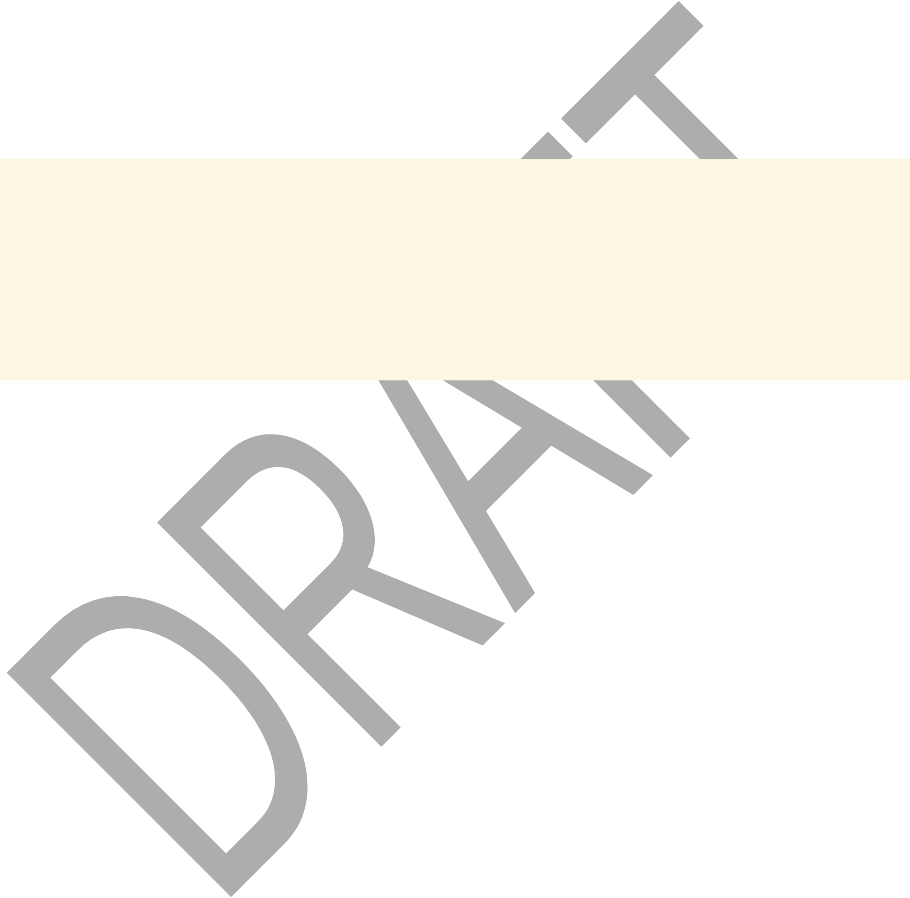
Indian Health Financing Series | Urban Indian Health Papers
Indian Health Financing Series
Paper VII
The Cost of Extending 100% FMAP to Urban Indian Organizations: A Program-Level Estimate
A Working Paper in the Indian Health Financing Series
Edward J. Fox, PhD
April 2026

Carved mask, gift to the author from the Port Gamble S’Klallam Tribe
Author's Note
This note presents an independent estimate of the federal cost of extending 100% Federal Medical Assistance Percentage to Urban Indian Organizations, based on 2015 program-level visit data. The author has direct experience with Indian health financing policy but limited direct operational experience with UIOs as program administrators. The analysis is offered as a methodological check on existing published estimates rather than a definitive accounting. Readers with current UIO billing and utilization data should treat the figures here as a 2015 baseline subject to updating.
Abstract
Two published estimates frame the current policy debate over permanent 100% FMAP for Urban Indian Organizations: the Congressional Budget Office estimate of approximately $941 million to $1 billion over ten years, and the National Council of Urban Indian Health estimate of approximately $547 million over the same period. Both are derived from top-down per-patient cost models applied to the full 41-UIO system.
This paper provides a program-level cost estimate using 2015 UDS visit data for the 32 UIOs that supplied primary care patient data, with each program’s actual state FMAP applied to the AI/AN Medicaid visit share. California, with its large UIO system and high non-Indian patient share, requires a blended rate mechanism rather than straight 100% FMAP; the California-specific analysis is addressed separately.
Using 2015 program-level visit data for 32 UIOs, the annual federal cost of extending 100% FMAP — the state share shifted to the federal government — is estimated at approximately $33–59 million annually depending on the Medicaid utilization rate assumed (50–90% of AI/AN visits). The blended rate mechanism for California and other states with significant non-Indian patient shares is addressed separately.
I. Background: Published Estimates and Their Limitations
The CBO Estimate
© 2026 Edward J. Fox, PhD | 16


Indian Health Financing Series | Urban Indian Health Papers
The Congressional Budget Office estimated the ten-year cost of permanent 100% FMAP for UIOs at approximately $941 million to $1 billion in its FY2021 scoring of Section 9815 of the American Rescue Plan Act. This estimate used a top-down per-patient methodology and applied the full 41-UIO count.
The NCUIH Estimate
The National Council of Urban Indian Health published an estimate of approximately $547 million over ten years, using T-MSIS administrative claims data for AI/AN patients at UIOs. The NCUIH estimate is methodologically stronger than the CBO estimate in that it uses actual Medicaid billing data rather than per-patient assumptions, and applies to the full 41-UIO system.
The Oklahoma Programs
Both published estimates include the Oklahoma City Indian Clinic (OKCIC) and the Indian Health Care Resource Center in Tulsa (IHCRC), and both programs are properly included in any FMAP cost estimate for UIOs. OKCIC and IHCRC are Title V IHCIA urban Indian
organizations — nonprofit corporations governed by community boards, holding IHS contracts administered through the Office of Urban Indian Health Programs. OKCIC was incorporated in 1974 as the Central Oklahoma American Indian Health Council, a multi-tribal nonprofit formed by Oklahoma City community leaders, physicians, and clergy responding to unmet health care access needs among AI/AN residents. IHCRC was incorporated in 1978 as an Oklahoma nonprofit on the recommendation of the Native American Coalition of Tulsa’s Health Committee, following a community survey documenting unmet medical needs in the Tulsa urban Indian population. Neither program was established by a federally recognized tribe assuming an IHS program under ISDEAA self-determination authority; both are community-organized, multi-tribal urban health organizations in the tradition of the post-relocation urban Indian health movement.
Both face the same FMAP gap as every other Title V UIO. A question sometimes raised is whether OKCIC or IHCRC might qualify as P.L. 93-638 Tribal programs on the basis of their 501(c)(3) status, but 501(c)(3) status and 638 contractor status are not mutually exclusive — the Northwest Portland Area Indian Health Board holds both simultaneously. The operative question is the legal authority under which the IHS contract is held. For OKCIC and IHCRC, that authority is Title V IHCIA, administered through the OUIHP, not ISDEAA. The IHS Urban Indian
Organization Infrastructure Study (2024) explicitly classifies both programs as “Urban Indian-only programs.”
The cost estimate in this paper uses 2015 UDS program-level data for the 32 UIOs that supplied primary care patient data to the Infrastructure Study, which represents the best available program-level dataset. OKCIC and IHCRC are among the 41 UIOs; the 32-program scope reflects the availability of program-level UDS data, not any legal distinction among programs.
II. Methodology
Data Source
© 2026 Edward J. Fox, PhD | 17

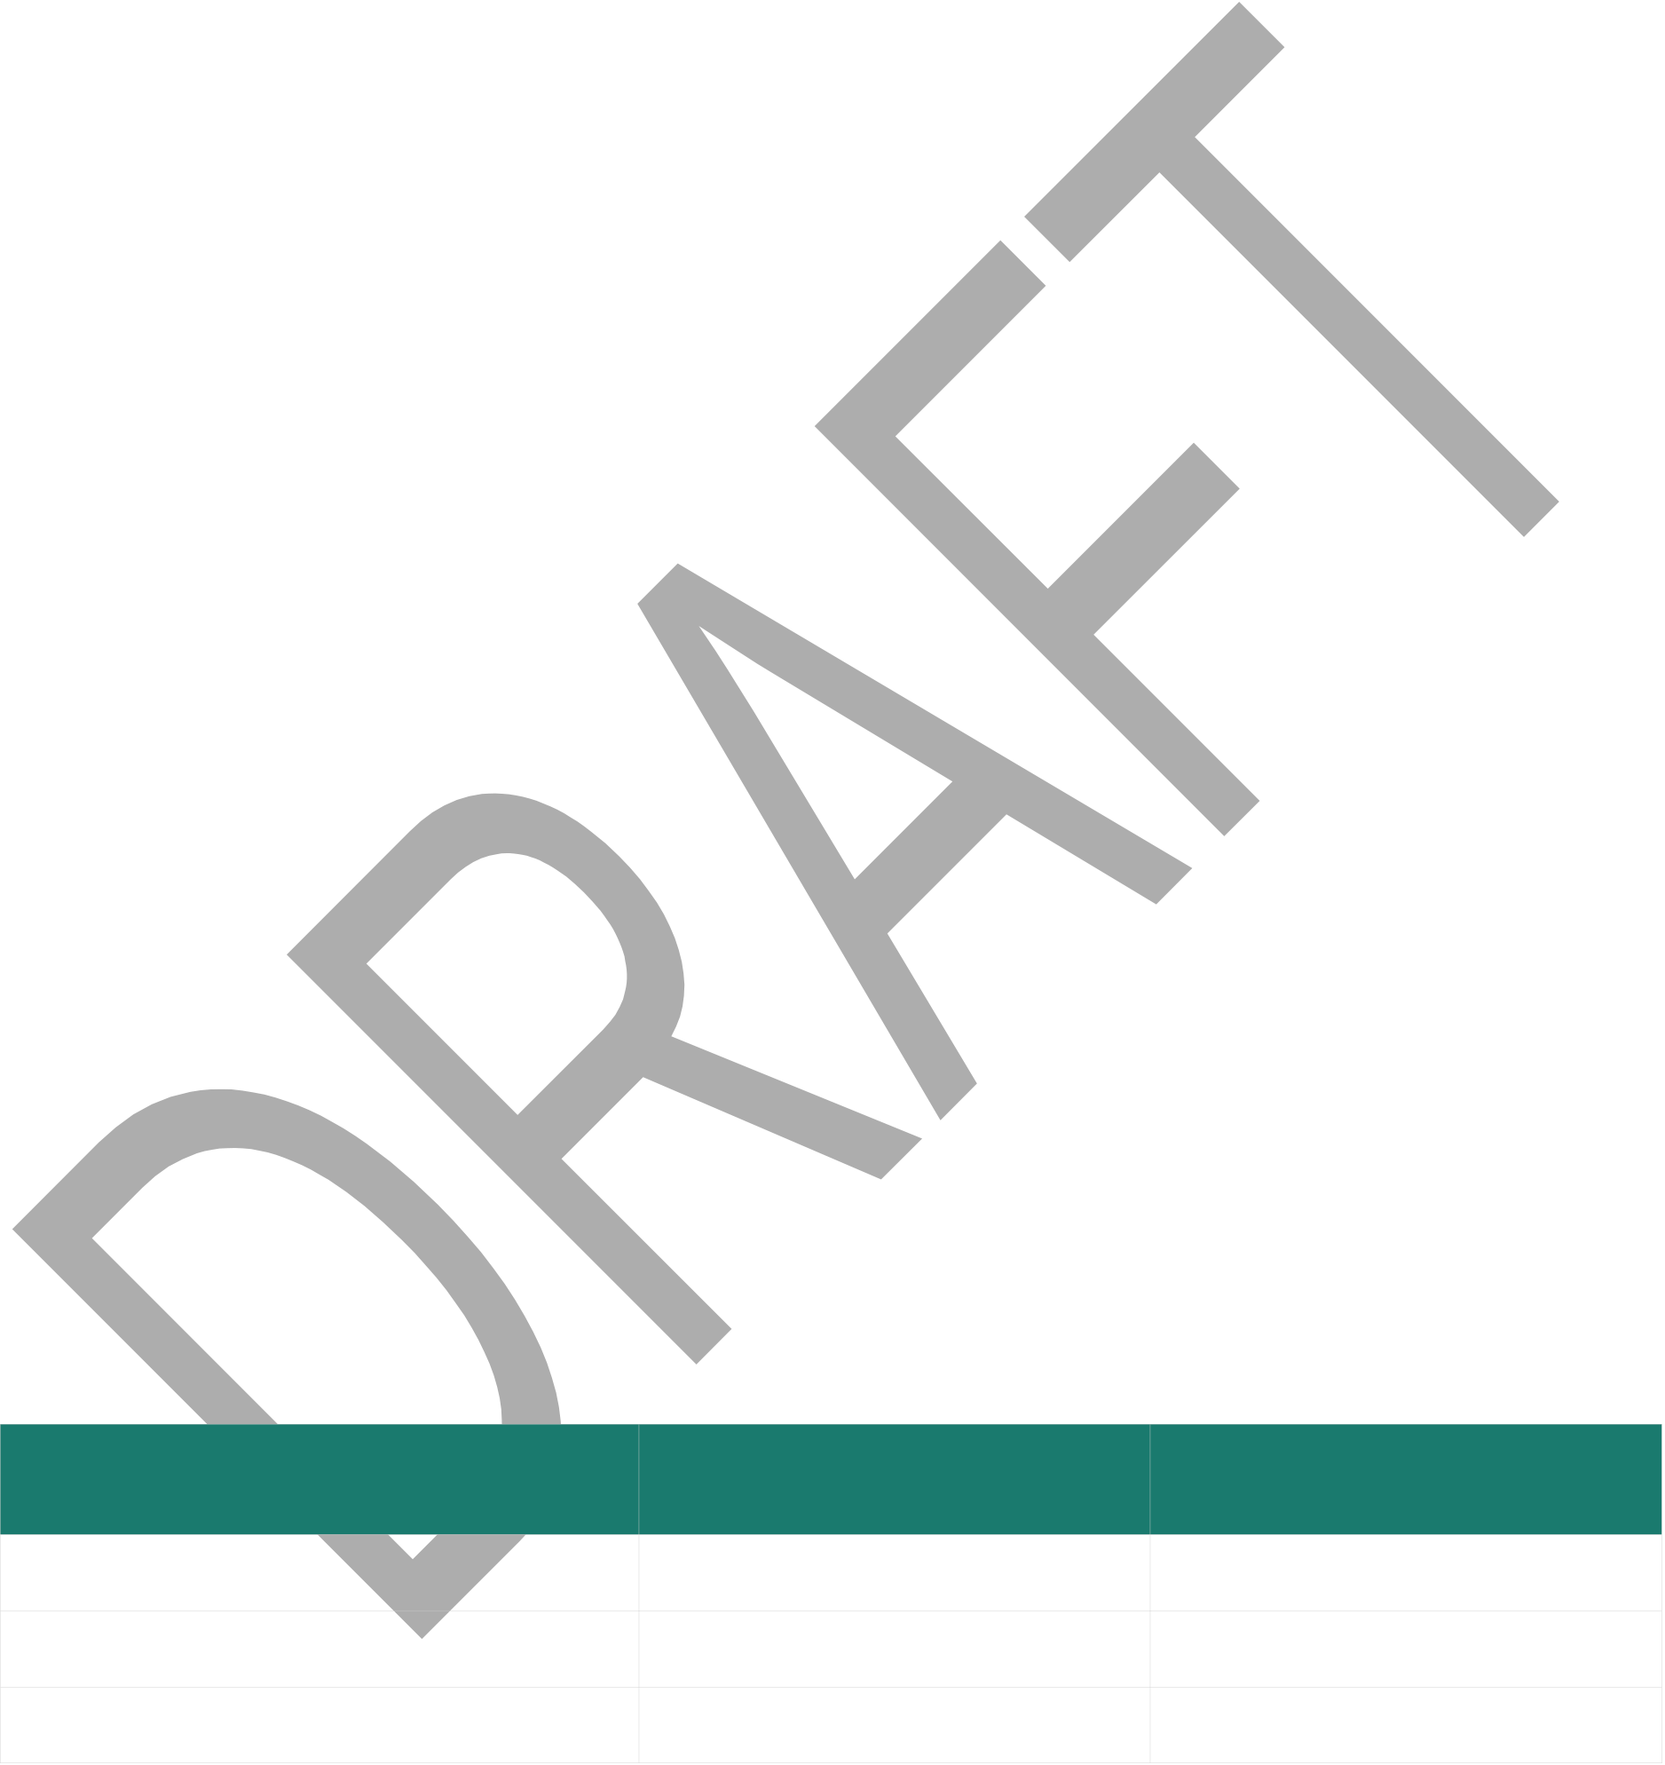
Indian Health Financing Series | Urban Indian Health Papers
The analysis uses the 2015 Urban Indian Organization National Uniform Data System (UDS) summary report, published by the IHS Office of Urban Indian Health Programs. The 2015 UDS provides program-level visit counts, patient counts, and payer mix data for the full UIO system. This is the most granular publicly available program-level dataset; more recent UDS data at the program level were not available for this analysis.
The Cost Calculation
Extending 100% FMAP to UIOs means the federal government assumes the state Medicaid share for AI/AN patients at UIOs. The incremental federal cost equals:
Incremental Federal Cost = (State FMAP share) × (AI/AN Medicaid visits) × (Medicaid reimbursement rate per visit)
For each UIO with available data, the calculation applies: (1) the state’s standard FMAP (i.e., the share currently paid by the state that would shift to federal), (2) estimated AI/AN Medicaid visit volume derived from UDS patient and utilization data, and (3) the FQHC Prospective Payment System rate applicable in that state.
Medicaid Utilization Assumption
The 2015 UDS does not report AI/AN Medicaid visits as a distinct line; it reports total visits and total Medicaid visits and patient counts by race/ethnicity in aggregate. This paper uses a sensitivity range of 50–90% of AI/AN patient visits being Medicaid-billable — a conservative floor assumption consistent with the IHS-access population's Medicaid coverage rates, with the upper bound reflecting high-Medicaid-dependency programs.
III. Findings
National Estimate (32 UIOs with Program-Level Data)
Using 2015 UDS program-level data for the 32 UIOs that supplied primary care patient data, the estimated annual incremental federal cost of extending 100% FMAP is approximately $33–59 million annually at 50–90% Medicaid utilization assumptions. The ten-year cost is approximately $330–590 million — substantially below the CBO ten-year estimate of $941 million–$1 billion, reflecting the use of program-level visit data rather than per-patient cost assumptions.
Medicaid Utilization Assumption | Annual Incremental Federal | Ten-Year Cost
Cost
50% (conservative floor) | ~$33M | ~$330M
70% (mid-range) | ~$46M | ~$460M
90% (high-Medicaid-dependency) | ~$59M | ~$590M
California Concentration
© 2026 Edward J. Fox, PhD | 18

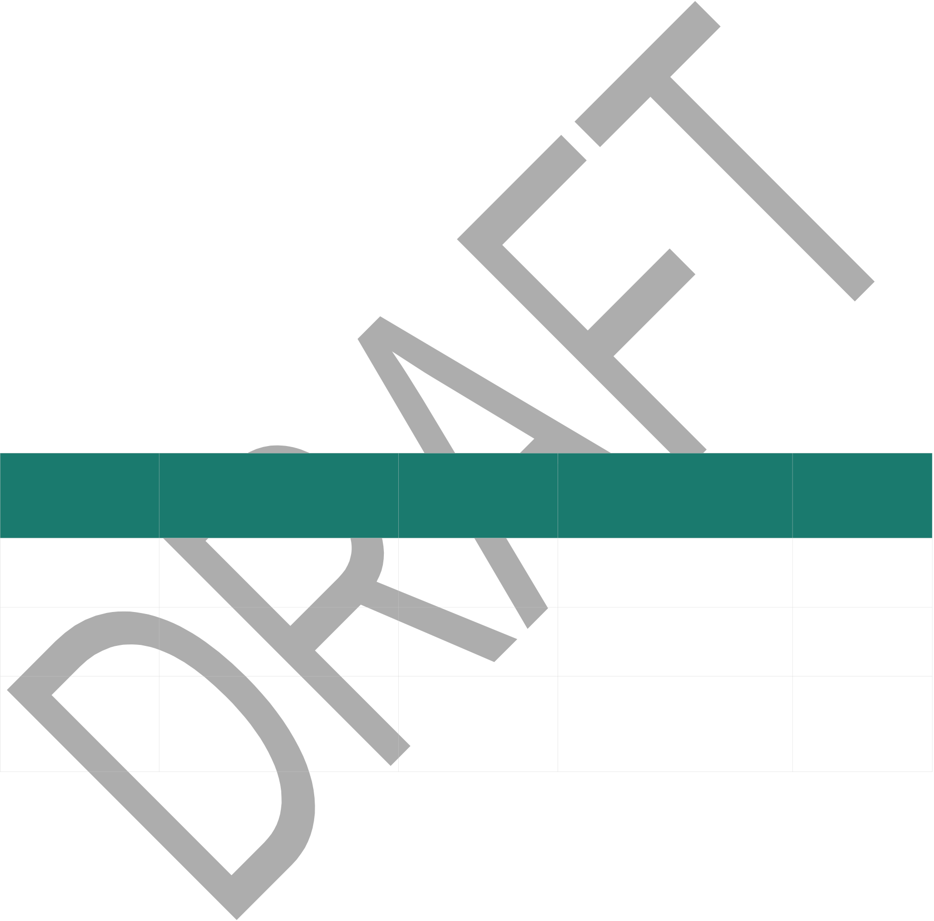
Indian Health Financing Series | Urban Indian Health Papers
California accounts for approximately 32% of the total estimated cost of extending 100% FMAP to the UIOs in the dataset, reflecting both the scale of California’s UIO system and the state’s relatively lower FMAP (meaning a larger state share currently). California also has the most significant non-Indian patient complication: several California UIOs serve patient populations that are 40–60% non-AI/AN due to their FQHC obligations.
A blended rate mechanism is required for California rather than straight 100% FMAP. The mechanism: (1) document the AI/AN patient share at each California UIO using IHS eligibility verification, (2) apply 100% FMAP to Medicaid claims for verified AI/AN patients, and (3) apply standard California FMAP (approximately 50%) to Medicaid claims for non-AI/AN patients. The net federal cost for California at 70% AI/AN utilization is approximately $15M annually.
OMB Rate Access
A separate but related policy question is whether UIOs should be permitted to bill Medicaid at the IHS all-inclusive encounter rate rather than the FQHC Prospective Payment System rate. IHS facilities bill at approximately $427 per visit (the 2015 OMB rate); FQHC PPS rates in the same period averaged approximately $287. Extending OMB rate access to UIOs would add approximately $8–14M annually to the federal cost on top of the 100% FMAP estimate — an incremental cost, not an alternative to it.
IV. Comparison with Published Estimates
Estimate | Source | 10-Year Cost | Methodology | Oklahoma
Programs
Included
CBO (2021) | Congressional Budget | ~$941M–$1B | Top-down per-patient | Yes — all 41
NCUIH (2023) | Office | ~$547M | model | UIOs
NCUIH (2023) | Natl. Council of Urban | ~$547M | T-MSIS administrative | Yes — all 41
This analysis | Indian Health | ~$330–590M | claims | UIOs
This analysis | Fox (2026), 2015 UDS | ~$330–590M | Program-level visit data | 32 UIOs with
This analysis | data | ~$330–590M | Program-level visit data | data (of 41
total)
The gap between this analysis and the CBO estimate reflects primarily the use of program-level visit data rather than per-patient cost assumptions. The gap with the NCUIH estimate is smaller and partly reflects data vintage (2015 UDS vs. more recent T-MSIS data). All three estimates carry significant uncertainty; the most defensible policy figure is a range of $33–59M annually rather than a point estimate.
V. Policy Implications
The cost of extending 100% FMAP to UIOs is modest relative to the obligation — approximately $46M annually at the mid-range estimate using 2015 program-level data. This compares to a
© 2026 Edward J. Fox, PhD | 19

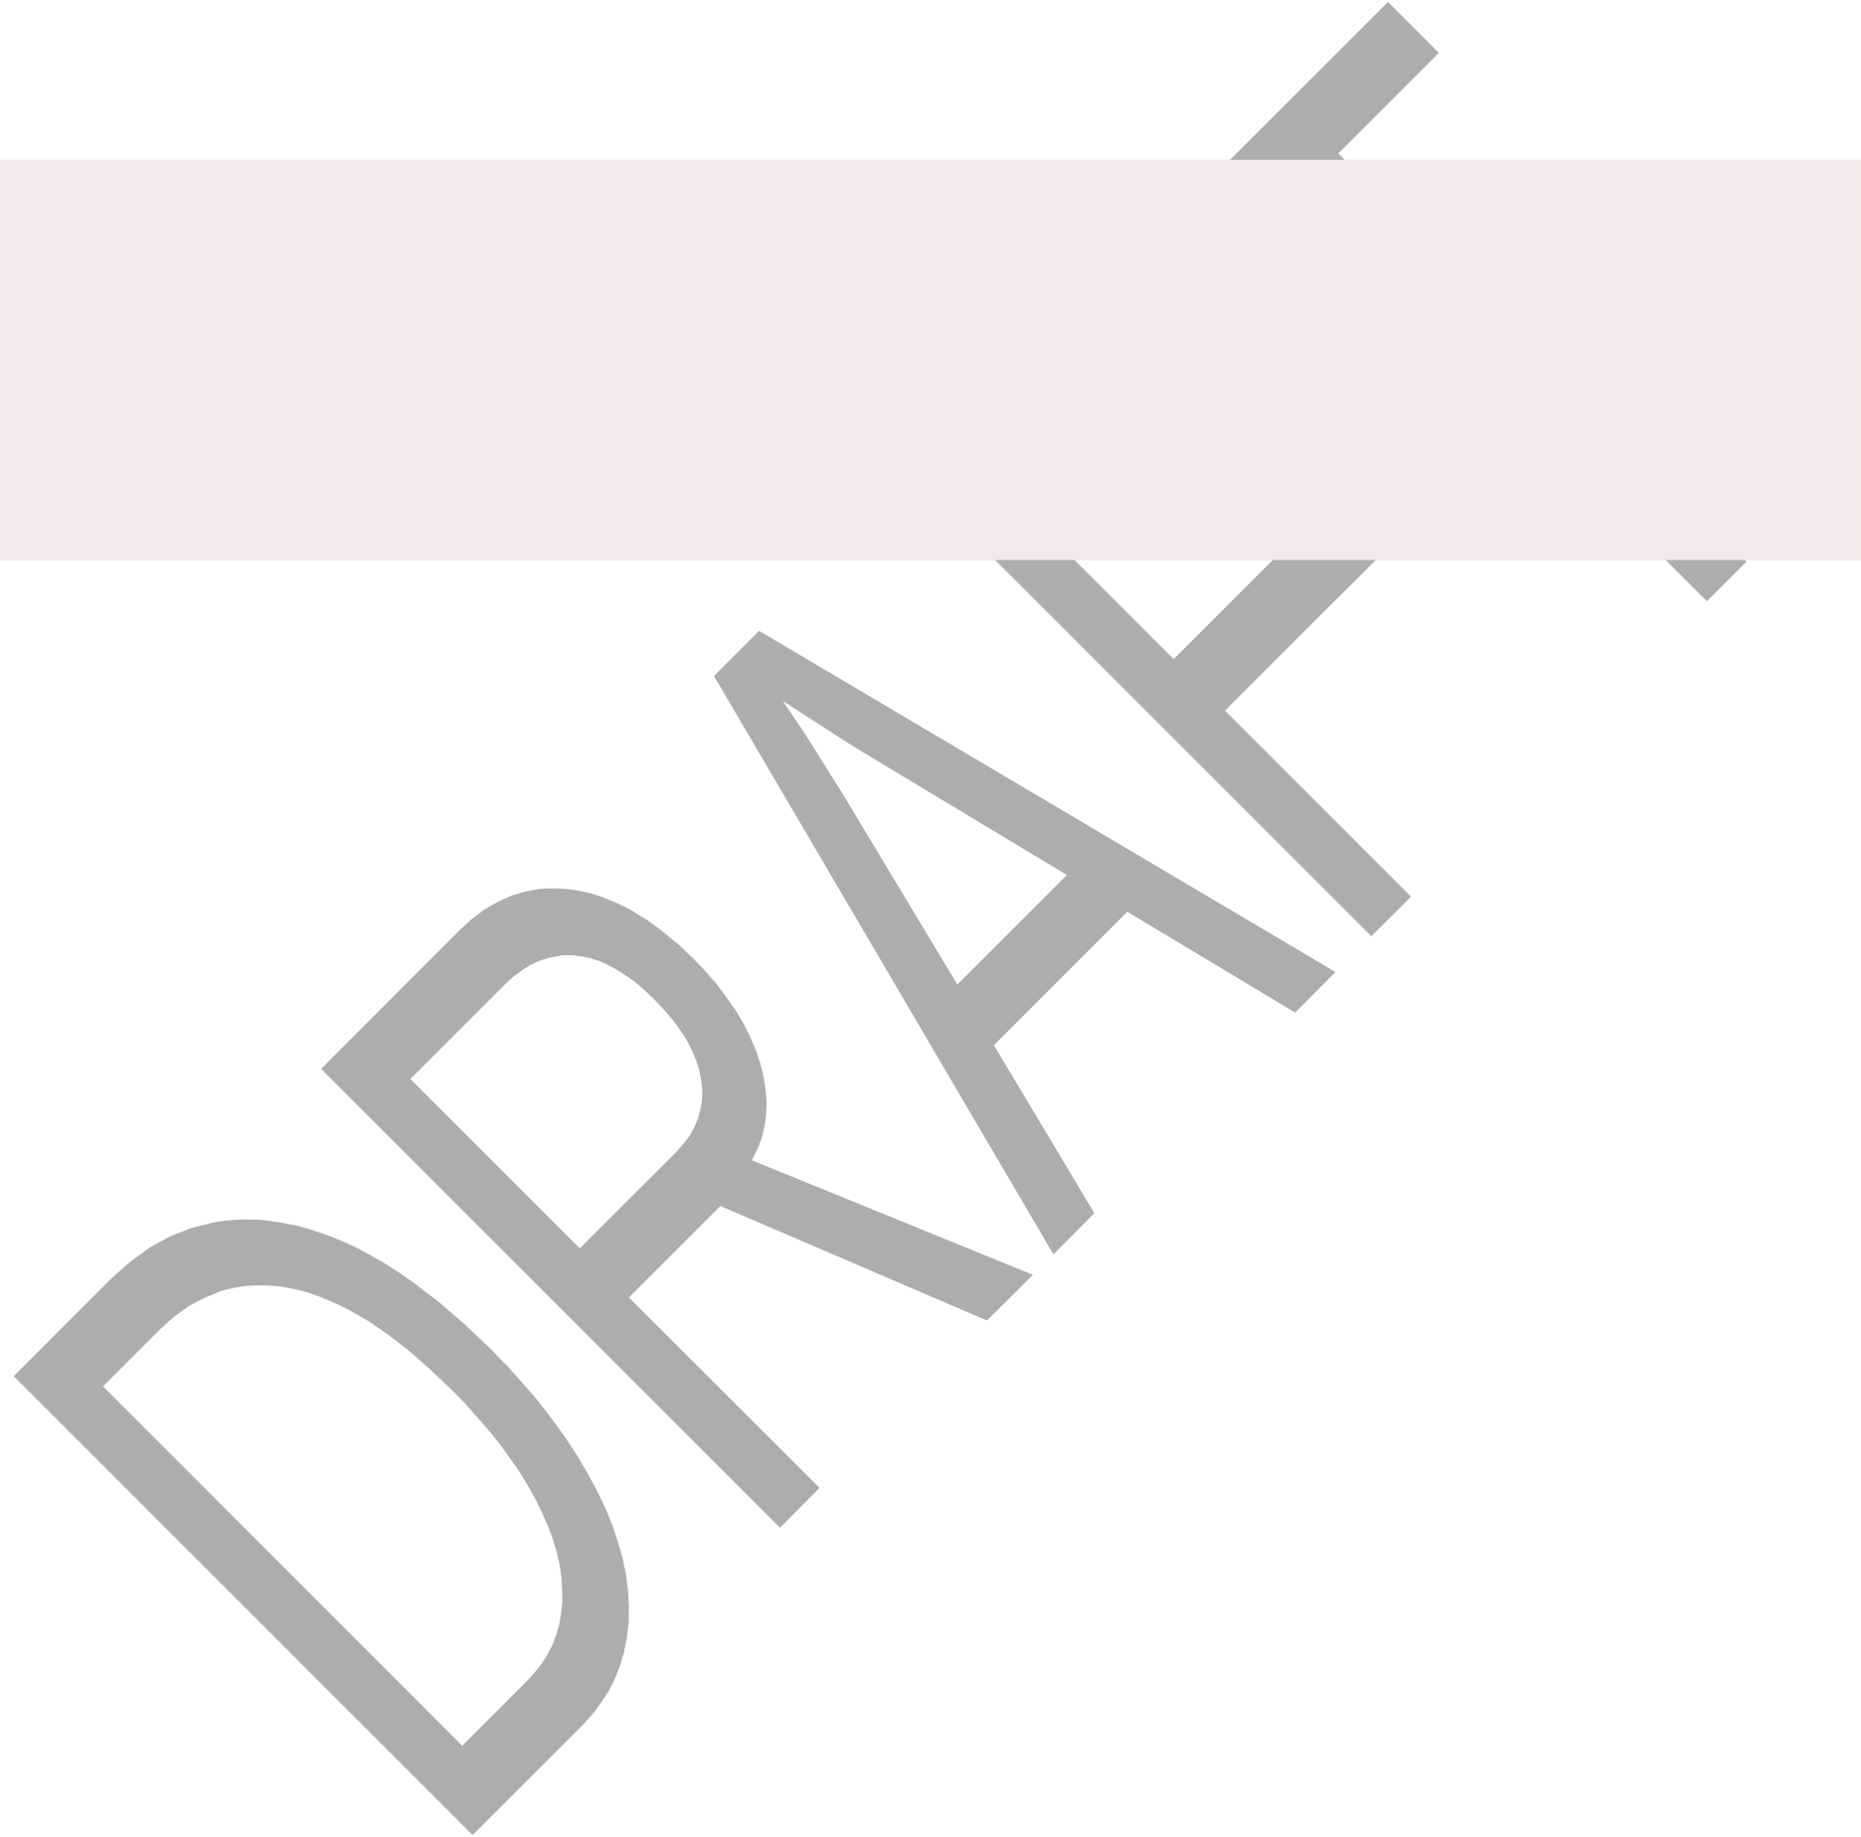
Indian Health Financing Series | Urban Indian Health Papers
total IHS appropriation of approximately $7.2B in FY2024. The 100% FMAP extension is not a fiscal stretch; it is the application of the trust responsibility Medicaid obligation to patients who happen to use a UIO rather than an IHS or Tribal facility.
The California blended rate mechanism is important as a policy design precedent. It
demonstrates that 100% FMAP extension does not require ignoring the non-Indian patient reality — it requires a verification-based patient-level determination, not a program-level blanket rule. This design is more legally defensible and more consistent with the trust responsibility rationale.
Legislative Context: H.R. 4722
The Urban Indian Health Parity Act (H.R. 4722) would permanently extend 100% FMAP to UIOs. The cost estimate in this paper supports the legislative case: the annual incremental federal cost is modest, the trust responsibility basis is well-established, and the program-level methodology grounds the estimate in actual visit data rather than per-patient cost assumptions. A blended rate mechanism for California and other high-non-Indian-share states can be incorporated into the legislative design.
References
Congressional Budget Office. (2021). Estimate of budgetary effects of Section 9815 of H.R. 1319, American Rescue Plan Act of 2021.
Fox, E. J. (2015). Urban Indian program cost estimate for 100% FMAP and right to bill at OMB all-inclusive encounter rate. Unpublished analytical memorandum.
Fox, E. J. (2026). Urban Indian health programs and the Indian health non-system: A structural analysis. Indian Health Financing Series, Paper VI.
Indian Health Service, Office of Urban Indian Health Programs. (2021). Urban Indian
Organization National Uniform Data System summary report, 2015. U.S. Department of Health and Human Services.
National Council of Urban Indian Health. (2023). An overview of Medicaid and healthcare for American Indians and Alaska Natives. NCUIH.
National Council of Urban Indian Health. (2023). States again shoulder the cost of an unmet federal trust responsibility. NCUIH.
© 2026 Edward J. Fox, PhD | 20

Indian Health Financing Series | Urban Indian Health Papers
Indian Health Financing Series
© 2026 Edward J. Fox, PhD | 21

